Se noteaza doar activitatea din cele doua ore de laborator
IP - L13. Testarea unei ierarhii de clase
Punctaj:

- Codul 0.2p  - Printscreen-urile 0.2p | - Concluziile 0.2p  - Testele (tabel + passed/failed) 0.4p
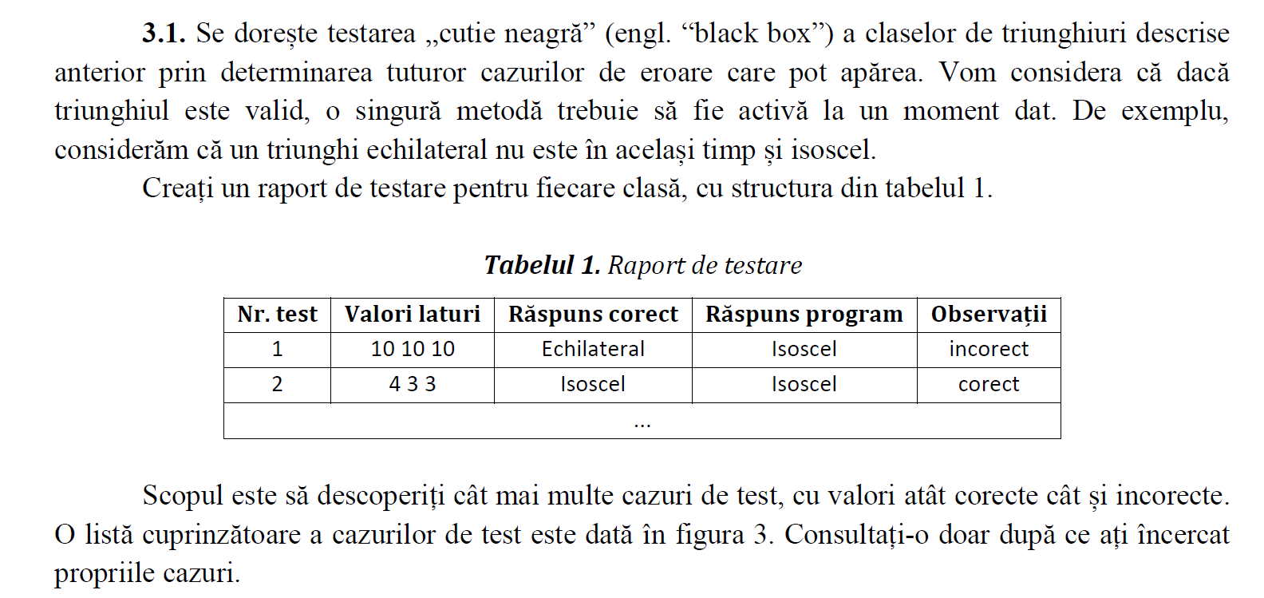
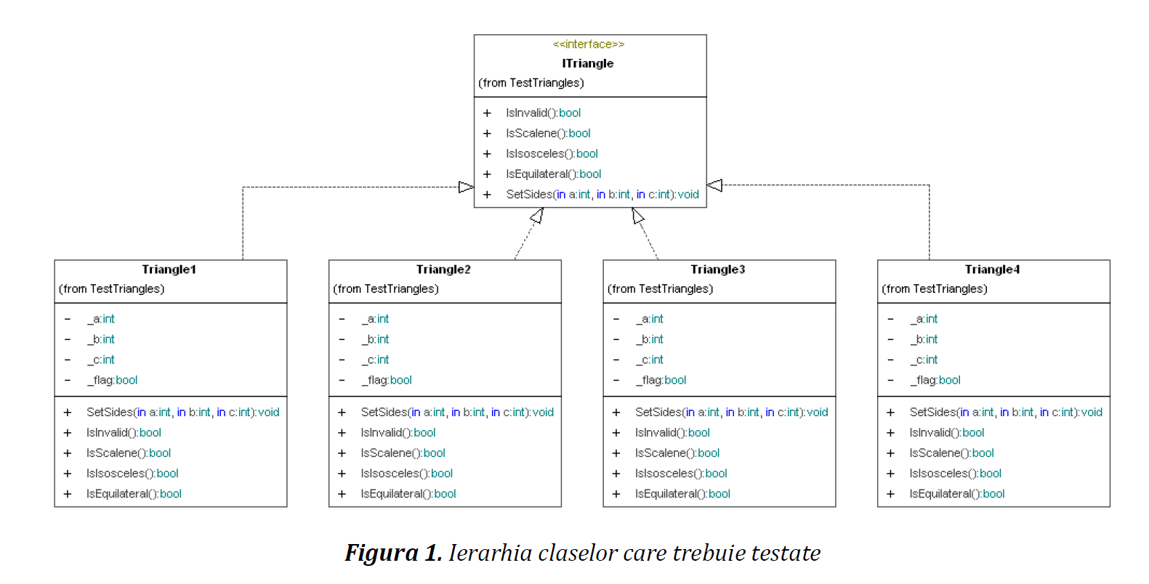

ITriangle.cs
namespace Triangles
{
public interface ITriangle
{
bool IsInvalid();
bool IsScalene();
bool IsIsosceles();
bool IsEquilateral();
void SetSides(int a, int b, int c);
}
}

Triangle1.cs
namespace Triangles
{
public class Triangle1 : ITriangle
{
int _a;
int _b;
int _c;
bool _flag;
public void SetSides(int a, int b, int c)
{
_a = a;
_b = b;
_c = c;
int semiperim = (a + b + c) / 2;
_flag = a == 0 || b == 0 || c == 0 || a < 0 || b < 0 || c < 0 || semiperim <= a ||
semiperim <= b || semiperim <= c;
}
public bool IsInvalid()
{
return _flag;
}
public bool IsScalene()
{
return _a != _b && _a != _c && _b != _c;
}
public bool IsIsosceles()
{
return _a == _b || _a == _c || _b == _c;
}
public bool IsEquilateral()
{
return _a == _b && _b == _c && !IsIsosceles();
}
}
}

Triangle2.cs
namespace Triangles
{
public class Triangle2 : ITriangle
{
int _a;
int _b;
int _c;
bool _flag;
public void SetSides(int a, int b, int c)
{
_a = a;
_b = b;
_c = c;
int semiperim = (a + b + c) / 2;
_flag = a == 0 || b == 0 || c == 0;
}
public bool IsInvalid()
{
return _flag;
}
public bool IsScalene()
{
return _a != _b && _a != _c && _b != _c;
}
public bool IsIsosceles()
{
return _a == _b || _a == _c || _b == _c;
}
public bool IsEquilateral()
{
return _a == _b && _b == _c;
}
}
}

Triangle3.cs
namespace Triangles
{
public class Triangle3 : ITriangle
{
int _a;
int _b;
int _c;
bool _flag;
public void SetSides(int a, int b, int c)
{
_a = a;
_b = b;
_c = c;
int semiperim = (a + b + c) / 2;
_flag = a < 0 || b < 0 || c < 0;
}
public bool IsInvalid()
{
return _flag;
}
public bool IsScalene()
{
return _a != _b && _a != _c && _b != _c;
}
public bool IsIsosceles()
{
return _a == _b || _a == _c || _b == _c;
}
public bool IsEquilateral()
{
return _a == _b && _b == _c;
}
}
}

Triangle4.cs
namespace Triangles
{
public class Triangle4 : ITriangle
{
int _a;
int _b;
int _c;
bool _flag;
public void SetSides(int a, int b, int c)
{
_a = a;
_b = b;
_c = c;
int semiperim = (a + b + c) / 2;
_flag = a == 0 || b == 0 || c == 0 || a < 0 || b < 0 || c < 0;
}
public bool IsInvalid()
{
return _flag;
}
public bool IsScalene()
{
return _a != _b && _a != _c && _b != _c;
}
public bool IsIsosceles()
{
return _a == _b || _a == _c || _b == _c;
}
public bool IsEquilateral()
{
return _a == _b && _b == _c;
}
}
}

EvaluateTriangle

TriangleUnitTests.cs
public abstract class TriangleUnitTests
{
protected ITriangle _triangle;
public abstract void Init();
[TestMethod]
public void ValidScalene()
{
// 1. Triunghi oarecare (scalen) valid
_triangle.SetSides(10, 8, 5);
Assert.AreEqual("100", EvaluateTriangle(), "10-8-5");
}
// ... celelalte teste
}

Triangle1UnitTests.cs
[TestClass]
public class Triangle1UnitTests : TriangleUnitTests
{
[TestInitialize]
public override void Init()
{
_triangle = new Triangle1();
}
}

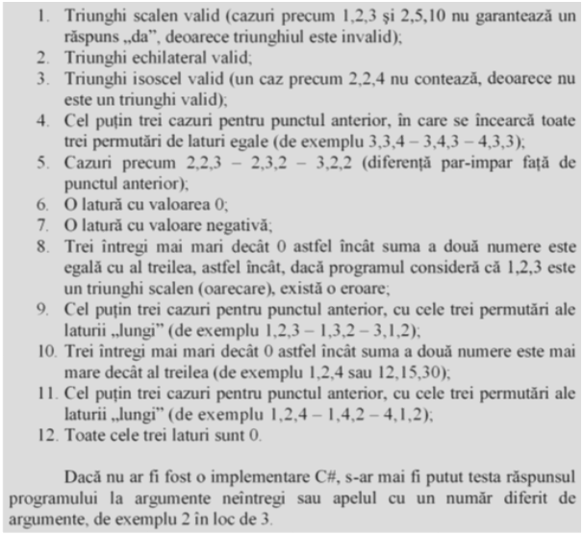
Proiect de tipul Unit Testing in .NET Framework
Pe References adaugati dll-ul care trebuie testat
Proiectul va contine 5 clase (interfata si triangle1-4)
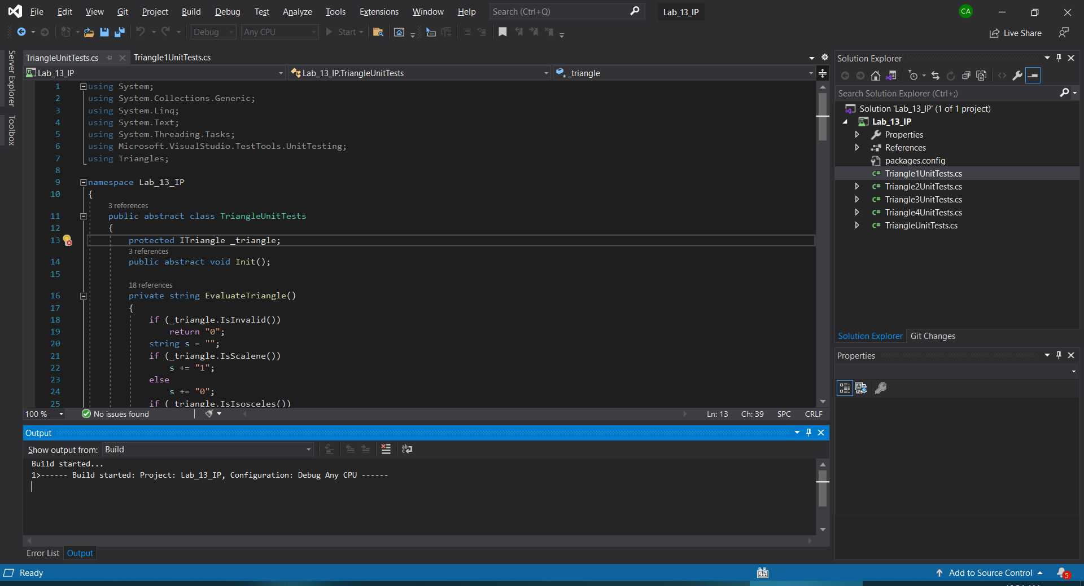
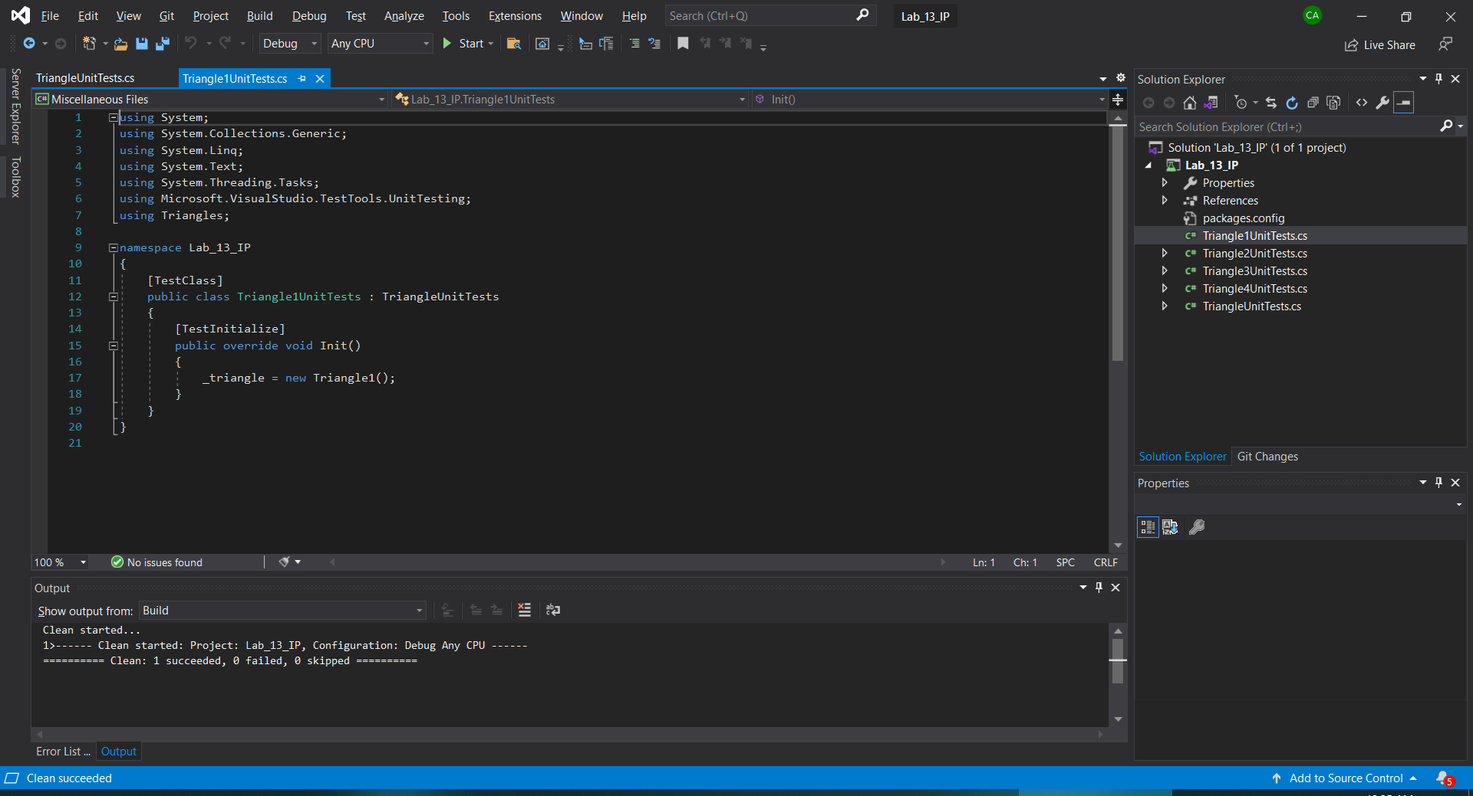

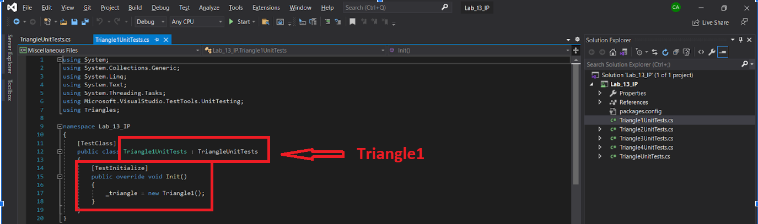

Se vor nota rezultatele testelor intr-un tabel de forma

Nr. crt. | Nr. test. | Laturile | Triangle1 | Triangle2 | Triangle3 | Triangle4
1
2

Prezentarea rezultatelor
- Codul pentru cazurile de test
using Microsoft.VisualStudio.TestTools.UnitTesting;
using System;
using Triangles;

namespace Lab_13_IP
{
[TestClass]
public abstract class TriangleUnitTests
{

protected ITriangle _triangle;
public abstract void Init();

private string EvaluateTriangle()
{
if (_triangle.IsInvalid())
return "0";
string s = "";
if (_triangle.IsScalene())
s += "1";
else
s += "0";
if (_triangle.IsIsosceles())
s += "1";
else
s += "0";
if (_triangle.IsEquilateral())
s += "1";
else
s += "0";
return s;
}

[TestMethod]
public void ValidScalene1()
{
_triangle.SetSides(10, 8, 5);
Assert.AreEqual("100", EvaluateTriangle(), "10-8-5 (Scalen valid)");
}

[TestMethod]
public void ValidScalene2()
{
_triangle.SetSides(5, 6, 7);
Assert.AreEqual("100", EvaluateTriangle(), "5-6-7 (Scalen valid)");
}

[TestMethod]
public void ValidEquilateral()
{
_triangle.SetSides(10, 10, 10);
Assert.AreEqual("001", EvaluateTriangle(), "10-10-10 (Echilateral valid)");
}

[TestMethod]
public void ValidIsosceles()
{
_triangle.SetSides(10, 15, 10);
Assert.AreEqual("010", EvaluateTriangle(), "10-15-10 (Isoscel valid)");
}

[TestMethod]
public void IsoscelesPermutation1()
{
_triangle.SetSides(3, 3, 4);
Assert.AreEqual("010", EvaluateTriangle(), "3-3-4 (Isoscel)");
}

[TestMethod]
public void IsoscelesPermutation2()
{
_triangle.SetSides(3, 4, 3);
Assert.AreEqual("010", EvaluateTriangle(), "3-4-3 (Isoscel)");
}

[TestMethod]
public void IsoscelesPermutation3()
{
_triangle.SetSides(4, 3, 3);
Assert.AreEqual("010", EvaluateTriangle(), "4-3-3 (Isoscel)");
}

[TestMethod]
public void IsoscelesOddPerimeter1()
{
_triangle.SetSides(2, 2, 3);
Assert.AreEqual("010", EvaluateTriangle(), "2-2-3 (Suma impară)");
}

[TestMethod]
public void IsoscelesOddPerimeter2()
{
_triangle.SetSides(2, 3, 2);
Assert.AreEqual("010", EvaluateTriangle(), "2-3-2 (Suma impară)");
}

[TestMethod]
public void IsoscelesOddPerimeter3()
{
_triangle.SetSides(3, 2, 2);
Assert.AreEqual("010", EvaluateTriangle(), "3-2-2 (Suma impară)");
}

[TestMethod]
public void OneSideZero()
{
_triangle.SetSides(0, 5, 5);
Assert.AreEqual("0", EvaluateTriangle(), "0-5-5 (O latură e 0)");
}

[TestMethod]
public void NegativeSide()
{
_triangle.SetSides(-1, 5, 5);
Assert.AreEqual("0", EvaluateTriangle(), "-1-5-5 (O latură e negativă)");
}

[TestMethod]
public void AllSidesZero()
{
_triangle.SetSides(0, 0, 0);
Assert.AreEqual("0", EvaluateTriangle(), "0-0-0 (Toate laturile sunt 0)");
}

[TestMethod]
public void SumEqualsThird1()
{
_triangle.SetSides(1, 2, 3);
Assert.AreEqual("0", EvaluateTriangle(), "1-2-3 (Laturi degenerate)");
}

[TestMethod]
public void SumEqualsThird2()
{
_triangle.SetSides(1, 3, 2);
Assert.AreEqual("0", EvaluateTriangle(), "1-3-2 (Laturi degenerate)");
}

[TestMethod]
public void SumEqualsThird3()
{
_triangle.SetSides(3, 1, 2);
Assert.AreEqual("0", EvaluateTriangle(), "3-1-2 (Laturi degenerate)");
}

[TestMethod]
public void SumLessThanThird1()
{
_triangle.SetSides(1, 2, 4);
Assert.AreEqual("0", EvaluateTriangle(), "1-2-4 (Nu formează triunghi)");
}

[TestMethod]
public void SumLessThanThird2()
{
_triangle.SetSides(1, 4, 2);
Assert.AreEqual("0", EvaluateTriangle(), "1-4-2 (Nu formează triunghi)");
}

[TestMethod]
public void SumLessThanThird3()
{
_triangle.SetSides(4, 1, 2);
Assert.AreEqual("0", EvaluateTriangle(), "4-1-2 (Nu formează triunghi)");
}

[TestMethod]
public void InvalidIsosceles()
{
_triangle.SetSides(10, 20, 10);
Assert.AreEqual("0", EvaluateTriangle(), "10-20-10 (Isoscel invalid)");
}

[TestMethod]
public void IntegerOverflow()
{
_triangle.SetSides(int.MaxValue, int.MaxValue, int.MaxValue);
Assert.AreEqual("001", EvaluateTriangle(), "MaxInt-MaxInt-MaxInt (Overflow test)");
}

}
}

- Printscreen/-uri cu rezultatele obținute 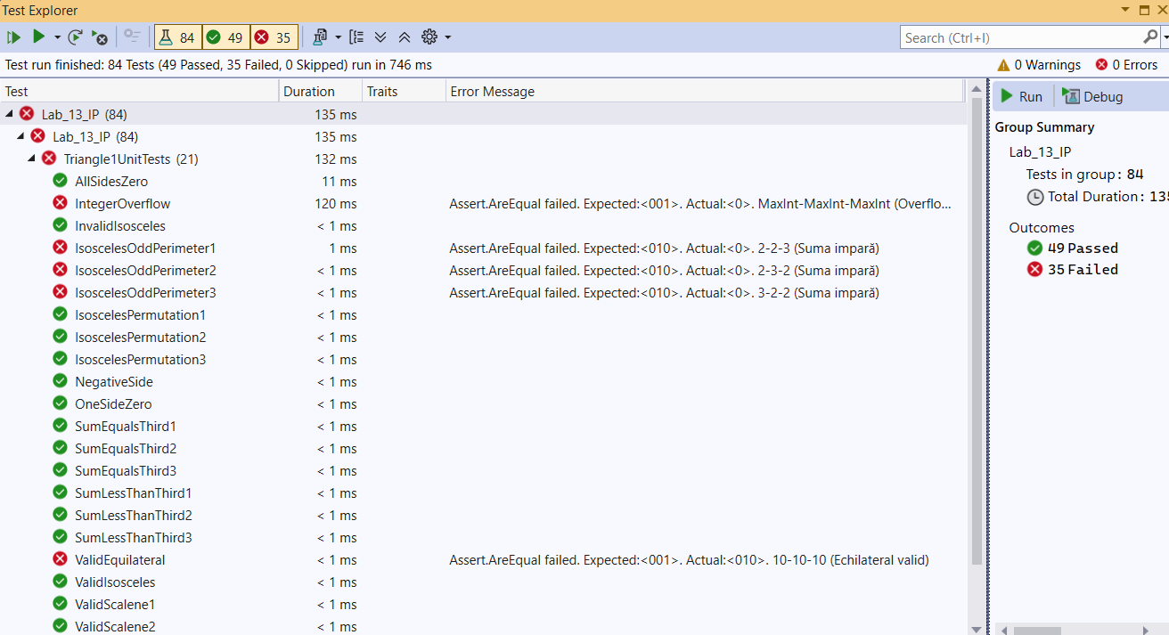 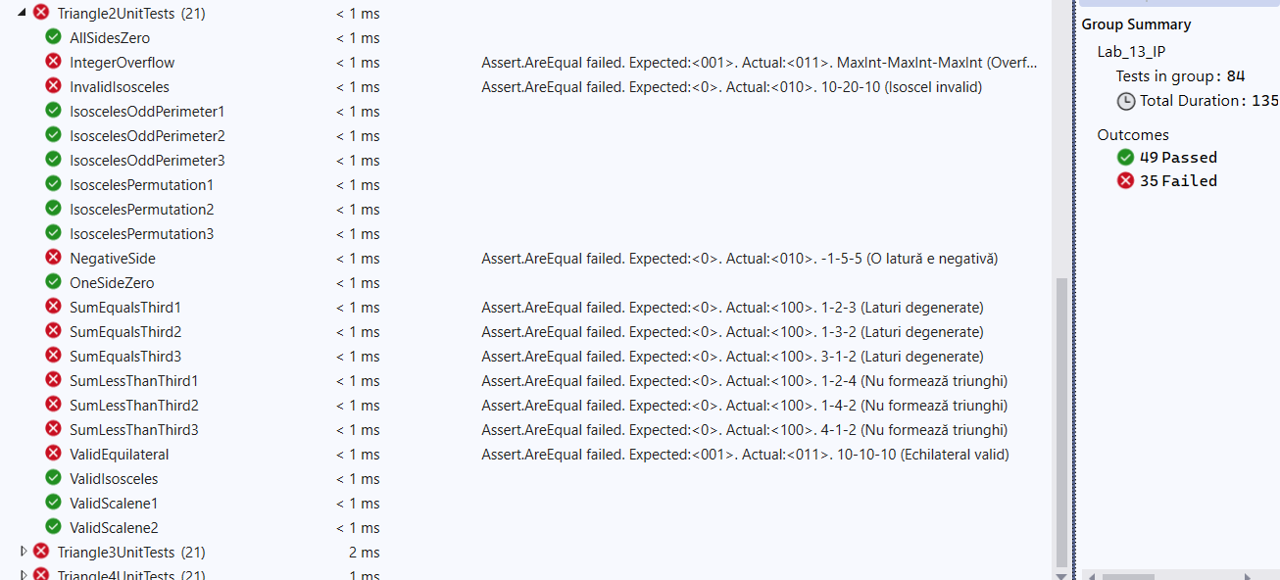 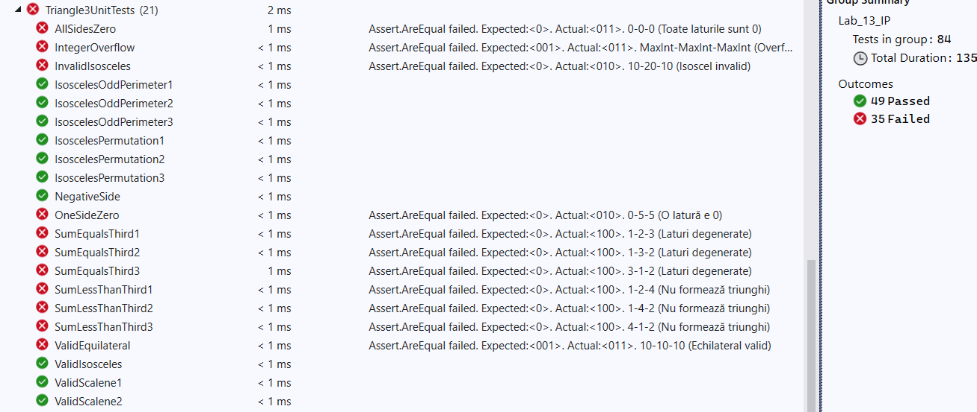 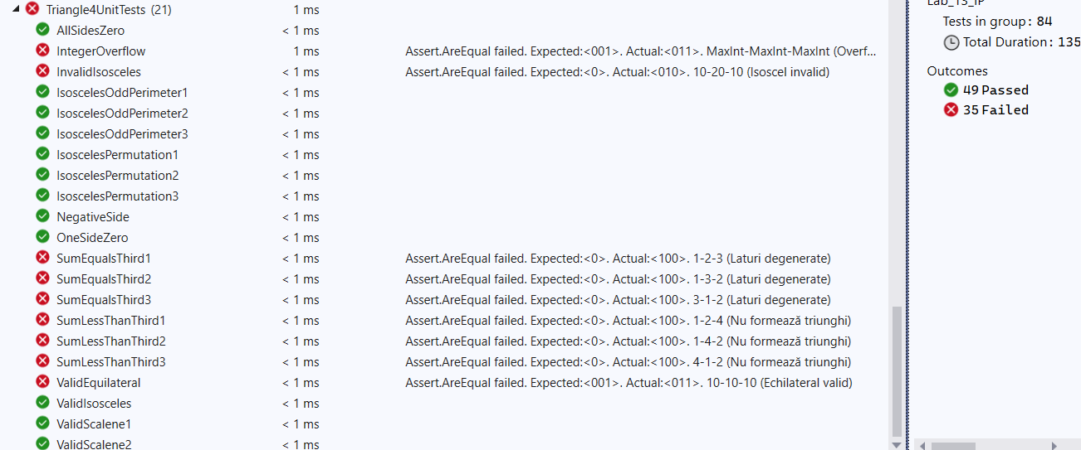

- Raportul de testare

- Plan de testare

Explicați principiile/ condițiile după care ați organizat testele, ce anume vizați să verificați asupra implementării din dll

Organizarea testelor a fost realizată pe baza principiilor testării de tip „cutie neagră”, având ca scop validarea comportamentului claselor din DLL (care implementează interfața ITriangle) strict prin prisma datelor de intrare și a rezultatelor returnate, raportat la cerințele matematice și logice ale unui triunghi.

Enumerați grupurile de teste aferente acestei organizări

- Rezultate

Nr test | Valori laturi | Răspuns corect  așteptat | Triangle 1 |  | Triangle 2 |  | Triangle 3 |  | Triangle 4
 |  |  | Răspuns program | Observații | Răspuns program | Observații | Răspuns program | Observații | Răspuns program | Observații
1 | 10, 8, 5 | 100 | 100 | corect | 100 | corect | 100 | corect | 100 | corect
2 | 10, 10, 10 | 001 | 010 | incorect | 011 | incorect | 011 | incorect | 011 | incorect
3 | 10, 15, 10 | 010 | 010 | corect | 010 | corect | 010 | corect | 010 | corect
4 | 3, 3, 4 | 010 | 010 | corect | 010 | corect | 010 | corect | 010 | corect
5 | 2, 2, 3 | 010 | 0 | incorect | 010 | corect | 010 | corect | 010 | corect
6 | 0, 5, 5 | 0 | 0 | corect | 0 | corect | 010 | incorect | 0 | corect
7 | -1, 5, 5 | 0 | 0 | corect | 010 | incorect | 0 | corect | 0 | corect
8 | 0, 0, 0 | 0 | 0 | corect | 0 | corect | 011 | incorect | 0 | corect
9 | 1, 2, 3 | 0 | 0 | corect | 100 | incorect | 100 | incorect | 100 | incorect
10 | 1, 2, 4 | 0 | 0 | corect | 100 | incorect | 100 | incorect | 100 | incorect
11 | 10, 20, 10 | 0 | 0 | corect | 010 | incorect | 010 | incorect | 010 | incorect
12 | 2, 3, 4 | 100 | 0 | incorect | 100 | corect | 100 | corect | 100 | corect
…

Total = 84
Trecute= 49
Picate = 35

